Friday 4 December 2015, 11:00

Room Y23, Geovetenskapens hus
Stockholm University
Svante Arrhenius väg 12
Juan-Camilo Acosta Navarro

will defend his thesis:

”Historical anthropogenic radiative forcing of changes in biogenic secondary organic aerosol”

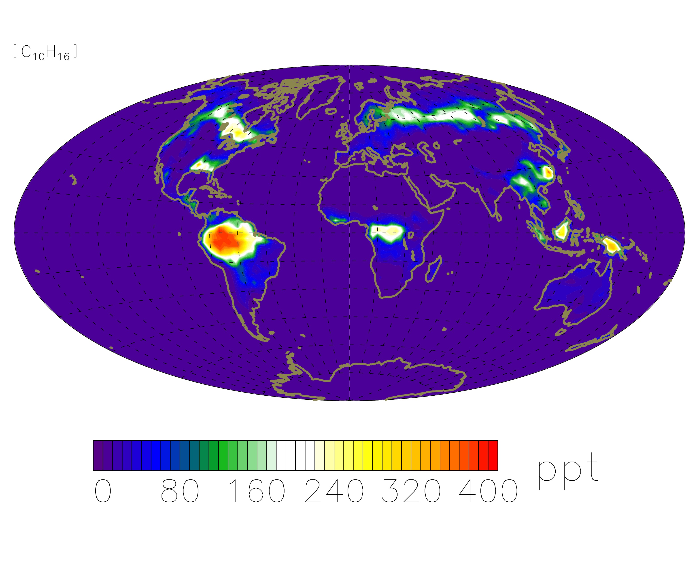

Most welcome

