Tuesday 17 November 2015, 10:00

William Olssonsalen, Geovetenskapens hus
Stockholm University
Svante Arrhenius väg 8
Henrik Olstrup

will defend his thesis:

”Carbonaceous particle metrics as indicators of adverse health effects – their limitations and needs of improvements”

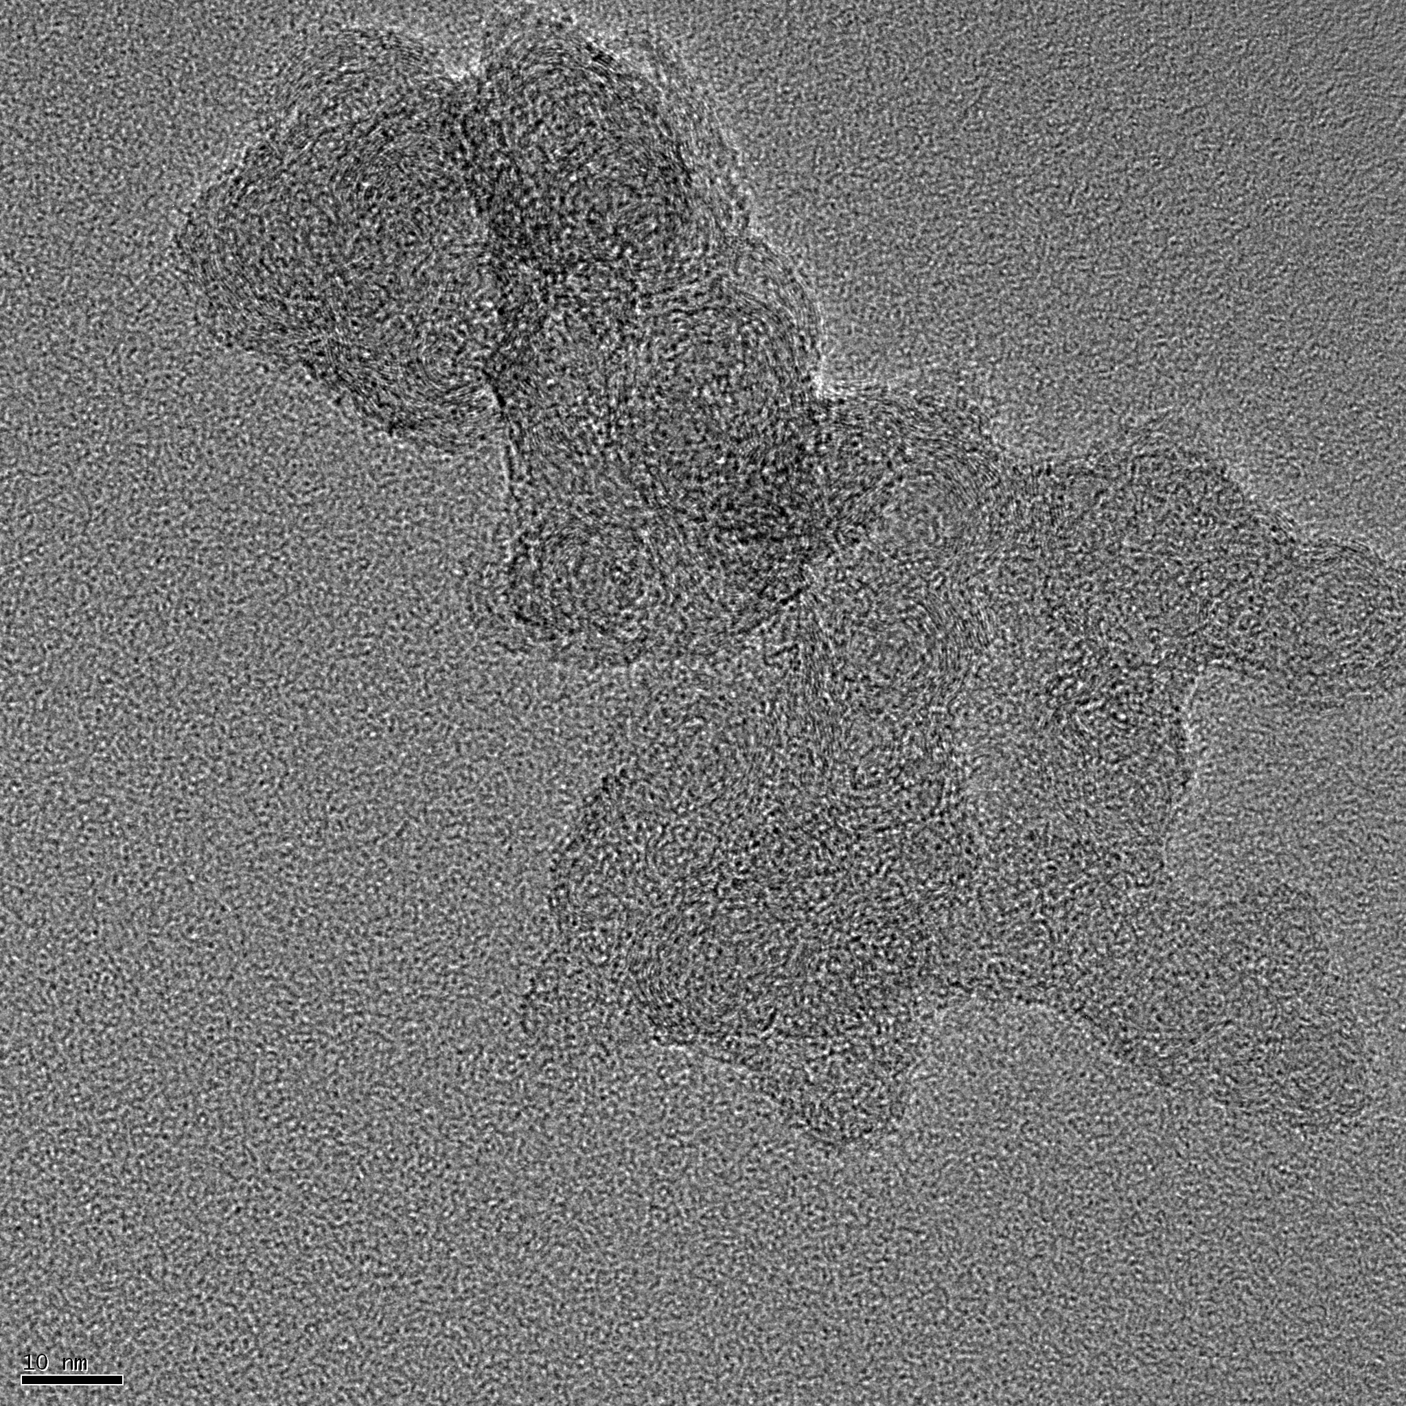

Most welcome

