28 May 2021, 10:00

De Geersalen, Geovetenskapens hus   
Stockholm University, Svante Arrhenius väg 14

and online

<https://stockholmuniversity.zoom.us/j/65850994813>

**Jannik Martens**

will defend his thesis:

“Remobilization of terrestrial carbon across temporal and spatial scales deduced from the Arctic Ocean sediment record”

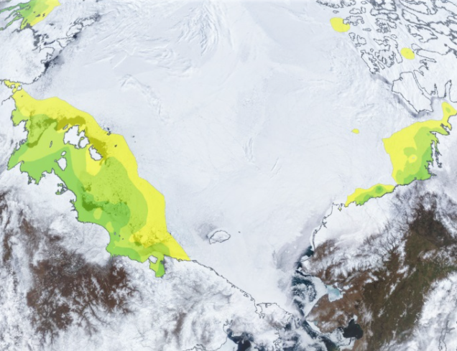

All are welcome to attend on Zoom!