Dear SciLifeLab group leader,

With regards to the upcoming SciLifeLab PULSE postdoc call, cohort 2, we at the SciLifeLab DDD platform would like to inform you that we have reserved resources to support up to 16 postdocs in the entrepreneurial track, but we need to collaborate with you as SciLifeLab group leaders to co-fund the salaries and additional costs at your labs for the PULSE postdoc candidates.

For us to use the funding reserved at DDD, we need the project to be aligned to one of our strategic areas for technology developments aiming to address challenges in drug discovery, see PULSE website:
- AI in Drug Discovery
- Proximity Inducing Agents
- Display and Selection Technologies
- Therapeutic Oligonucleotides.

For postDoc projects in the entrepreneurial track, we are looking for technologies in these areas, rather than developing a drug for a particular target/disease.

Support and collaboration terms
The DDD platform offers substantial support to successful candidates:

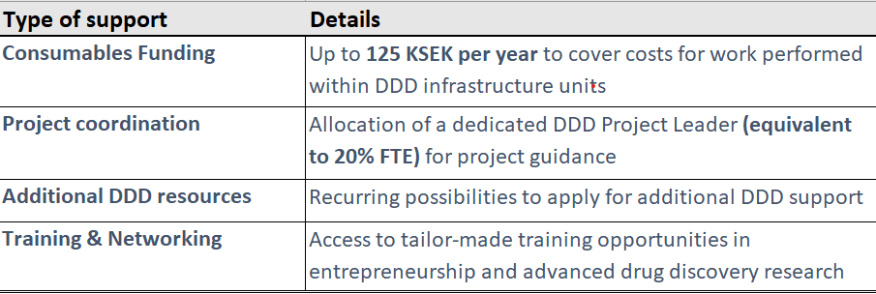

Note that DDD units may also function as a host for PULSE postDocs secondments.

Intellectual Property Rights (IPR) and Licensing: The Principal Investigator/Postdoc will retain full ownership of all generated IPR and the lead role in commercialization efforts. In exchange, the DDD platform is granted a non-exclusive, royalty-free license to utilize the developed technology in its forthcoming internal DDD programs.

Illustrative Scope of Technology Development: Examples of technologies in scope for the 2025 call included, but were not limited to: cyclic peptide libraries for proximity induction; AI-driven design and discovery of novel peptides; targeted delivery systems for oligonucleotide therapeutics; AI methodologies for high-throughput hit-finding via combined ultra-large DNA-encoded and virtual libraries; and bi-specific antibodies designed for membrane receptor degradation.
We strongly encourage you to propose candidates for the Entrepreneurial Track if you are planning to host a PULSE postdoc in 2026 whose research aligns with our defined technology development requirements.
For further detailed information regarding the PULSE Entrepreneurial Track, please direct inquiries to kristian.sandberg@scilifelab.uu.se.
We look forward to partnering with you to drive cutting-edge technological advancements in drug discovery.

